LAB # 3 (CIRCUIT DIAGRAMS)

Circuit # 1:
1. Measure Current between R1 and R2, and Voltage across R1, R2.
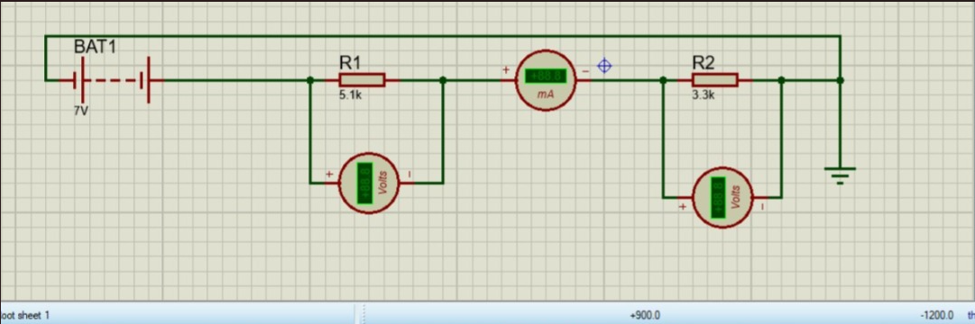

Circuit # 2:
2. Measure Current at node 2 and 3 and Voltage across R1, R2, R3.
